10/100M Fast Ethernet Media Converter (Single Mode Single Fiber)

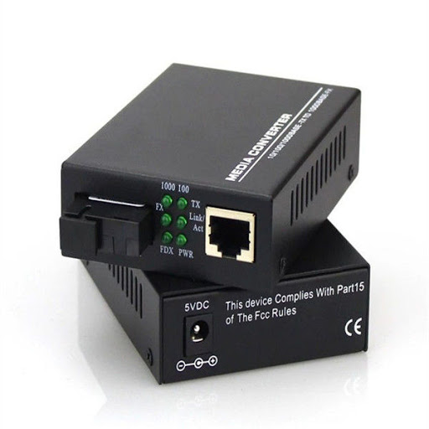

Product Brief：
Fiber Transceiver is 10/100Mbps media converter which realizes conversion between 10Base-T UTP and 10Base-FL optical cable (Single Fiber) or 10Base-T UTP and 100Base-FX optical cable. It is suitable for intelligent residential area or connection between optical cable and desk-top. With the feature of auto-negotiation 10Mbps and 100Mbps, easy upgradation for users, it extends the limit network transmission distance from 100 meters of UTP cable to over 80Km

Features:
Comply with IEEE 802.3 10BaseT, 802.3u 100BaseTX,802.3u 100BaseFX
Transmit and receive over one fiber
TP-port rate 10M/100M bps auto-negotiation
LED indicators on the front panel for easy error diagnose
Offer single RJ-45 port MDI/MDIX auto-crossover.
Support full duplex and half duplex
Surface Mount Technology
MTBF: 50,000 hours

Specification:
Ethernet Port:
Connector: One RJ45(Female),
Rate:10/100M bps
Full/Half duplex auto-adaptive ,MDI/MDI-X
Optical Port:
Connector:SC
Wavelength: 1310nm / 1550nm
Tx Power: -10 dBm
Rx Sensitivity: -36 dBm
Optical power dynamic range: 25 dB
Allowed max link loss : 22 dB
USB power supply 5VDC 0.5A
Ambient Temperature: 0 ~ 70
-Humidity: 5 ~ 90%

Working Temperature: 0-50¡æ
Humidity: 5-90%(non-condensing)
Power Supply: External, AC 100V-260V, DC 5V 1A (Inner power supply available upon request)
EMI: FCC Class A CE Mark
Size: 116*70*26 mm

Part No | Description of product
Standalone series
WT-OTE-1315S-20 | 10/100M bps, SM, Simplex fiber,0-20KM,SC(1550/1310),Card
WT-OTE-1315S-40 | 10/100M bps, SM, Simplex fiber,0-40KM,SC(1550/1310),Card
WT-OTE-1315S-60 | 10/100M bps, SM, Simplex fiber,0-60KM,SC(1550/1310),Card
WT-OTE-1315S-80 | 10/100M bps, SM, Simplex fiber,0-80KM,SC(1550/1310),Card
Card series
WT-OTE-1315S-20 | 10/100M bps, SM, Simplex fiber,0-20KM,SC(1550/1310),Card
WT-OTE-1315S-40 | 10/100M bps, SM, Simplex fiber,0-40KM,SC(1550/1310),Card
WT-OTE-1315S-60 | 10/100M bps, SM, Simplex fiber,0-60KM,SC(1550/1310),Card
WT-OTE-1315S-80 | 10/100M bps, SM, Simplex fiber,0-80KM,SC(1550/1310),Card

